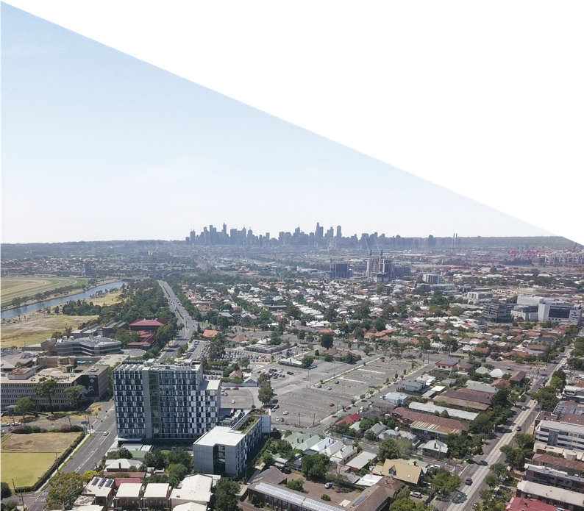

October 2019

**New Footscray Hospital Project**

Consultation report: the next people’s hospital

New Footscray Hospital Project

Consultation report: the next people’s hospital

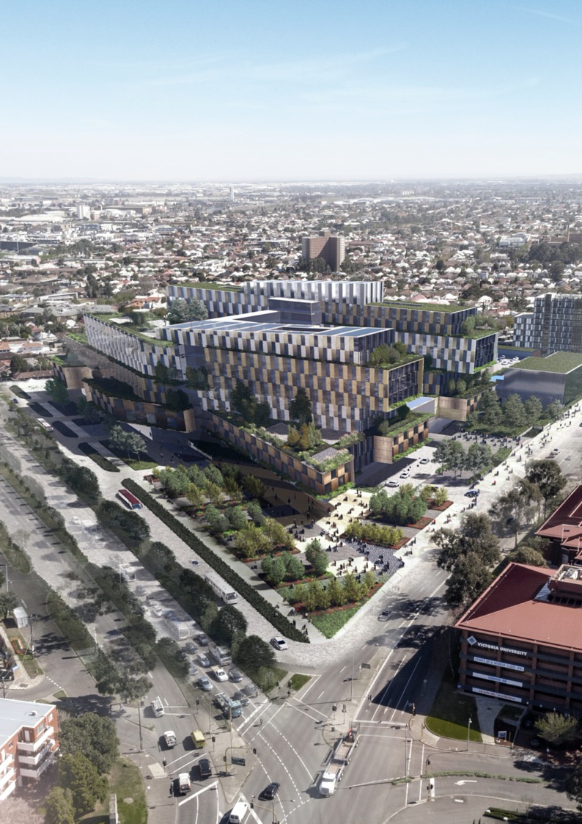

*This is an artist’s impression of the new Footscray Hospital only and does not reflect the State’s design preference.*

Page 2 New Footscray Hospital Project

Consultation report: the next people’s hospital

# What it means to build a hospital for Footscray

Since June 2019, the New Footscray Hospital Community Consultative Committee has worked to put forward the hopes, desires and aspirations of Melbourne’s inner west to help shape this significant investment. As passionate members of this community, we’ve prioritised ideas for key spaces and helped define what it means to build a hospital for Footscray.

When completed, the new Footscray Hospital will be a significant part of our community - that is multicultural, unpretentious and proud of our

working-class roots and diversity. We’re laidback, but also edgy, dynamic and vibrant. While gentrification is taking place, we feel much of the ‘original’ western suburbs remain.

We hope that the new Footscray Hospital is a place that complements and enhances our local environment, particularly the Maribyrnong River and the valley it has carved through the basalt. We want a hospital that does more than just serve our health needs, but also connects us with our community’s heritage both Indigenous and non-Indigenous.

We understand the opportunity for the new hospital to be a gateway for this community, and therefore we hope it complements and connects with the Footscray CBD, public transport, unique green spaces, bike paths, art and culture that surrounds it.

We talked about an environmentally friendly design, with innovative technology to provide the very best care for patients. We also hope our new hospital is designed, built and operated in a way that allows for contributions by local communities and partnerships with community health providers and local businesses.

Within the hospital, we’d like to see green spaces, cultural and Victorian Aboriginal artwork, the use of natural light and views of the river. Good

pedestrian and transport links are also important to us, with adequate parking at a reasonable price.

We’ve worked hard on behalf of the community to come up with ideas and priorities that we think are important to helping the new Footscray Hospital become a welcoming facility that supports the delivery of world class healthcare. It’s been a wonderful opportunity to help shape the development of our new hospital that will support the wellbeing of Melbourne’s inner west for generations to come.

### The New Footscray Hospital Community Consultative Committee



New Footscray Hospital Project

Page 3

Consultation report: the next people’s hospital

Page 3

Page 4 New Footscray Hospital Project

Page 4

Consultation report: the next people’s hospital

# Contents

|  |  |
| --- | --- |
| Introduction | **6** |
| Community engagement | **7** |
| How we engaged | **8** |
| Engagement timeline | **9** |
| What we heard | **10** |
| What we’re doing next | **13** |
| Conclusion | **14** |

Page 5

# Introduction

## Project background

The Victorian Government has provided up to

$1.5 billion to deliver the 504-bed (599 Points of Care) new Footscray Hospital on the corner of Geelong and Ballarat roads in Footscray – the largest ever health capital investment in this State.

The new Footscray Hospital will replace the existing Footscray Hospital on Gordon Street and ensure that demand for health services in Melbourne’s inner west is met into the future.

The new Footscray Hospital will be an elective and emergency hospital that will become increasingly expert in the provision of treatment for chronic disease, as well as enhancing its teaching and research capacity.

The hospital will provide a full range of medical and surgical specialties for adult patients, with a focus on new models of care for patients with chronic and complex medical conditions.

The hospital will comprise:

* at least 504 inpatient beds (including same- day, multi-day, critical care, subacute, drug and alcohol, mental health and palliative care services)
* acute facilities (including an emergency department with a Mental Health and Alcohol and other Drugs hub)
* specialist facilities (including interventional suites, operating theatres, procedural

and endoscopy spaces and associated recovery spaces)

* clinical support spaces
* carparking facilities for staff, patients and visitors
* teaching, training and research spaces.

When opened, the new hospital is expected to cut waiting times and allow almost 15,000 additional patients to be treated each year and almost 20,000 additional people to be seen by the emergency department each year.

It will also ease demand pressures on hospitals in inner Melbourne, as many patients currently bypass the existing Footscray Hospital and seek treatment in Melbourne’s CBD.

The New Footscray Hospital Project (Project) will be procured as a public private partnership

(PPP) under the Partnerships Victoria Framework. Construction of the new Footscray Hospital is scheduled to commence in 2020, with the hospital to be operational in 2025.

## Purpose of report

The Victorian Health and Human Services Building Authority (VHHSBA) is committed to working closely with stakeholders and the community to ensure

key issues are identified and views and aspirations are captured, with the opportunity for these to be reflected in the design, construction and operations of the new Footscray Hospital.

This report provides an overview of the work undertaken by VHHSBA to engage and consult with the community and key stakeholders and seek their ideas, priorities and potential concerns relating to the development of the new hospital.

This report has been provided to Shortlisted Respondents preparing proposals to design, construct, finance and maintain the new Footscray Hospital, and will assist with the ‘delivery of a vibrant community asset that enhances liveability and fosters collaboration in education, training and research’ – one of the State’s key Project Objectives.

By understanding the ideas and priorities of Melbourne’s inner west – including the broader community, local residents and the staff and volunteers of Western Health – Respondents will have the greatest opportunity to design and build a new hospital for Footscray that reflects the community it serves.

The scope of this report includes all engagement activity from the initial authorisation of the Project to September 2019, ahead of the announcement of Respondents shortlisted to prepare proposals to delivery this important Project.

Page 6 New Footscray Hospital Project

Page 6

Consultation report: the next people’s hospital

# Community engagement

The Victorian Government values community input and is committed to keeping the local community involved and up to date as the Project progresses.

## Engagement objectives

The key consultation objectives were to:

* raise awareness of the Project, its scope and timelines
* provide stakeholders with the opportunity to provide input into elements of the Project’s development
* understand key impacts and areas of concern for the community related to the Project.

## Influencing the design of the new Footscray Hospital

The consultation process has sought and considered advice on a range of issues relating to the new hospital, including use of public spaces, amenity, local culture and the vision and aspirations of the community.

The ideas and priorities (as well as issues and concerns) captured in this report have been provided to Shortlisted Respondents preparing proposals to design, construct, finance and maintain the new Footscray Hospital, so there is the opportunity for them to be considered in this process.

## Scope of engagement

During key stages of the Project, community members, local residents and the staff and volunteers of Western Health have been engaged and provided an opportunity to share their feedback.

This engagement has included activity to:

* **Inform and consult** through a series of engagement sessions in 2018 and early 2019. The sessions called on the institutional knowledge of Western Health staff and volunteers and ensured the local community had the opportunity to ask questions and raise any concerns.
* **Collaborate** with the New Footscray Hospital Community Consultative Committee (CCC), established to provide a voice for Melbourne’s inner west community and provide considered advice on a range of issues relating to the

new hospital.

* **Collaborate** with Western Health Aboriginal Health Unit staff to seek ideas and priorities for the new hospital in relation to cultural sensitivity.

## New Footscray Hospital Community Consultative Committee

A CCC has been established for the Project, providing a forum for members of the local community to participate in the Project’s planning and development through open dialogue and consultation.

Chaired by Katie Hall MP, Member for Footscray, the CCC meets regularly to provide input into the development of this important Project.

## Communications and Engagement Working Group

A joint VHHSBA / Western Health Communication and Engagement Working Group has been established as part of the Project’s governance structure and is responsible for the coordination, development and management of the Project’s communications and engagement activities.



Page 7

# How we engaged

VHHSBA, alongside Western Health, conducted extensive stakeholder and community engagement activity during the development of the business case for the Project and site selection process. Over 1,000 pieces of feedback were gathered to inform the development of the Project, with engagement activity including:

* + information sessions with Western Health staff and volunteers
  + ‘pop up’ information sessions at Footscray Hospital and Highpoint Shopping Centre
  + an Engage Victoria survey titled ‘Planning for western Melbourne’s future health needs’
  + community engagement sessions at Maribyrnong Aquatic Centre to provide Project updates and seek input into specific elements of the hospital, including traffic, wayfinding and the use of internal and external space
  + six community information sessions in early 2019, including a tailored information session for culturally and linguistically diverse individuals and groups and Auslan services
  + a facilitated session with staff from Western Health’s Aboriginal Health Unit to seek ideas and priorities for a culturally safe and inclusive new hospital
  + working sessions with the New Footscray Hospital CCC.

Engagement activity was promoted via the Project’s website, social media, advertisements in local papers and letterbox drops to residents where possible.

Attendees at information sessions and respondents to the survey were also asked if they wanted to

be kept informed about the Project. An email database of over 1,500 names and addresses has been established, and Project newsletters will be distributed at key milestones.

## Community Consultative Committee working sessions

The CCC has met four times, including an induction session on 25 June 2019. The CCC has participated in two working sessions to generate and prioritise ideas for the new Footscray Hospital.

### Working session 1: Key spaces in the new Footscray Hospital

In July 2019, the CCC participated in its first working session to help shape the development of the new Footscray Hospital. The meeting was held at Joan Kirner Women’s and Children’s Hospital.

The Committee worked in groups to generate and prioritise ideas around the following key spaces:

* indoor spaces
* outdoor spaces
* arriving at / departing from the hospital (wayfinding).

Altogether, the collaborative process produced 227 ideas, with each group voting for those they found the most important.

### Working session 2: What does it mean to build a hospital for Footscray?

In August 2019, the CCC convened for its next working session at the Footscray Community Arts Centre. The Minister for Health, The Hon.

Jenny Mikakos MP, attended the meeting and met members of the Committee to hear their ideas.

The Committee worked in groups, completing the following sentences to generate and

prioritise ideas:

* I am proud to be from Melbourne’s inner west because...
* The unique things about Melbourne’s inner west are...
* When building the new Footscray Hospital, my greatest hopes are...
* Building the new Footscray Hospital will mean...

During the session, the CCC collaborated to produce 231 ideas and thoughts, with each group voting for those they found the most important.

The CCC will continue to meet regularly throughout the Project’s development and delivery.

Page 8

# Engagement timeline

**December 2017** 4,420 newsletters distributed to community



Workshop with Western Health staff and volunteers

#### January 2018

**March 2018**

**April 2018**

Communications and Engagement Working Group established

Information session held with Western Health

Pop-up information sessions at Footscray Hospital and Highpoint Shopping Centre

Community engagement workshop

**May 2018** Engage Victoria online survey

Planning and site selection

Project development and procurement

#### October 2018

**February 2019**

**March 2019**

**April 2019**

**May 2019**

**June 2019**

**July 2019**

**August 2019**

**September 2019**

**Election commitment**

Information session with Western Health staff and volunteers Community Information Session (CIS) 1

Information session held with local residents and hospital visitors

CIS 2

CIS 3

CIS 4

CIS 5

#### Project funded (2019–20 State Budget)

CIS (Multicultural)

Session with interpreters provided

**Invitation for Expressions of Interest released** Community Consultative Committee (CCC) announced CCC meeting 1

Project update newsletter CCC meeting 2

CCC meeting 3

CCC meeting 4

Page 9

New Footscray Hospital Project

Consultation report: the next people’s hospital

Page 9

# What we heard

Page 10



## Vision and aspirations

The Project is one of the most significant developments in the history of Melbourne’s inner west. The vision and aspirations of the community were heard throughout the consultation process, and CCC members participated in a working session to define their greatest hopes for a new hospital in Footscray.

### What we heard

* A hospital that we can be proud of.
* A welcoming space and healing atmosphere, with the flexibility to change and adapt with the people who use it.
* Greater self-sufficiency for the region.
* An improvement in the patient experience to provide the best standards of care to promote healing and wellbeing.
* Setting of a new standard for development around Footscray.
* Increased medical education opportunities.
* More employment opportunities.

**Outdoor spaces**

* Green spaces.
* All-weather areas.
* Public art.
* Garden with trees and variety of soothing scented plants/flowers.
* Exercise spaces.
* Connecting the hospital to nearby existing spaces, such as Victoria University and Footscray Park.

**Wayfinding**

* Easy to navigate and intuitive.
* Public transport links.
* Access to Tiernan Street and Droop Street.
* Ease of pedestrian access.
* Adequate and safe lighting in outdoor areas.
* Sheltered drop off/pick up.
* Use of technology in wayfinding, for example, apps and free wifi.
* Colour-coded, linguistically diverse wayfinding.
* Universal design principles in signage and wayfinding.
* Multi-lingual or symbolic signage within the hospital and the nearby area that considers the cultural and linguistic makeup of western Melbourne.
* Safe and easy pedestrian connections across the busy Geelong Road and to and from tram and bus interchanges.

**Key spaces and services**

* Playgrounds for children.
* Adventure parks or barbeque areas.
* Different spaces for different weather.
* Indigenous-themed garden.
* Large forecourt.
* Active spaces for rehabilitation.
* A range of open and contained outdoor spaces to meet the varied needs of patients and visitors.

Throughout the consultation and engagement sessions, the community provided suggestions relating to key spaces.

Additionally, the CCC worked to generate and prioritise ideas around:

* + indoor spaces
  + outdoor spaces
  + arriving at / departing from the hospital.

### What we heard

**Indoor spaces**

* A less clinical ‘look and feel’ to internal spaces.
* Clear separation of patient/public areas and the desire for contrast between medical and non-medical areas.
* Integration of indoor/outdoor spaces.
* Adequate equipment storage.
* Spaces for patient and family use.
* Natural light and green space to evoke a healthy environment.
* Artworks from Victorian Aboriginal communities.
* Wayfinding ideas including colour-coded zoning, symbolic signage, clearly marked information desks and a free app with a full, interactive map.
* Publicly accessible retail space.
* Local library supplying books.
* Patient privacy.

**Services**

* Wellness facilities such as a gym for hospital users and local residents.
* Complementary facilities such as retail and specialist rooms.
* Clean, affordable accommodation for visitors.
* Links to local organisations, such as Western Bulldogs Football Club.
* Bike paths to connect to surrounding areas.

Page 11

## Cultural safety

The Western Health Aboriginal Health Unit sees a diverse range of patients from across Australia. On arrival at the hospital, patients appreciate a welcoming Indigenous space that makes them feel safe.

### What we heard

**Key issues**

Many of the key issues raised by community members – such as funding, location and the delivery timeframe – were resolved following the announcement of the Project in May 2019. However, there are consistent themes – such as public transport and parking – that are important to understand and address as the Project develops.

VHHSBA will keep the community and stakeholders informed of key activities relating to the design and construction of the new hospital and address any issues directly, where possible.

**Indoor spaces**

* Artwork provides ‘a visual statement that this organisation cares about Aboriginal people’.
* Floor-based artwork could be located at the main entrance or near the Aboriginal Health Unit, and Indigenous artworks could be used as a wayfinding device throughout the hospital.
* Artwork should also be used on wards to make Aboriginal people feel welcome while they receive treatment.
* It is best if seating is located against the wall to create a safe and inclusive environment.
* Artwork should be by Victorian artists.
* The Aboriginal Health Unit should be located close to the entrance and easily identifiable.
* The Aboriginal Health Unit should provide a mix of spaces for people to connect – including larger spaces for families to gather and have a cup of tea/coffee, small/ quiet spaces, and a space for meetings or clinical consultations if patients don’t feel comfortable going up to the ward.

### What we heard

**Key issues**

* Ability for hospital to cope with future population demands.
* Future use of the current Footscray Hospital site*.
* Noise during construction.
* Construction impact on traffic.
* Lack of accommodation for people visiting the hospital.
* Adequate and affordable parking.
* Congestion and public transport on Droop Street.

*Following relocation to the new site (corner of Ballarat and Geelong Roads), the current Footscray Hospital on Gordon Street will be decommissioned. The future use of the Gordon Street site is unknown at this time. The new Footscray Hospital will take approximately five years

to deliver, which provides time to bring the community, government and local organisations together to determine the best outcome for Footscray.

**Outdoor spaces**

* An Indigenous garden with native plants.
* A dedicated place that is peaceful, open and calm and allows people to connect to country.
* A place that is family-centred and big enough for a group to gather in.
* A place that long-term patients can spend time in.
* A place close to or adjoining the Aboriginal Health Unit – enabling use by patients, families and staff.
* A flagpole for displaying the Aboriginal flag.

Page 12

# What we’re doing next

The Project is on track to appoint a successful consortium in 2020 to design, construct, finance and maintain the new Footscray Hospital.

Construction is scheduled to commence in late 2020, with the new Footscray Hospital to open its doors in 2025.

The Victorian Government is committed to ongoing engagement with the community, and further information sessions will be held as the Project progresses.

The New Footscray Hospital Project is a major infrastructure project. VHHSBA will work with the successful consortium, other government departments and the community to minimise

disruptions to neighbouring residents, businesses and Victoria University staff and students.

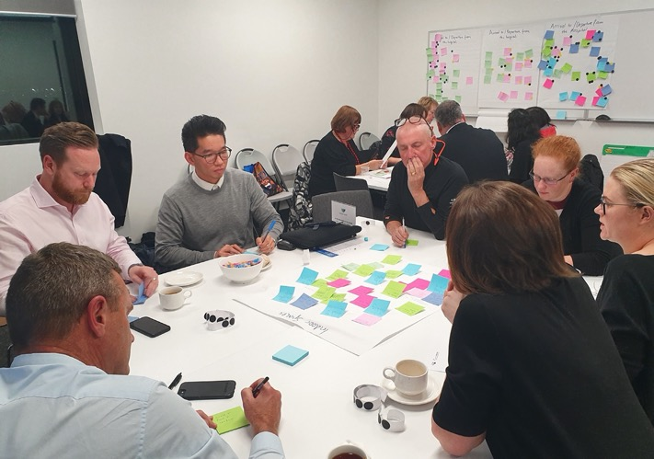

*The New Footscray Hospital Community Consultative Committee*

The New Footscray Hospital CCC will continue to meet regularly to provide community feedback at key milestones and receive Project updates.

The Project website and VHHSBA social media channels will continue to be updated regularly as the Project develops. Additionally, a Project newsletter will be distributed at key milestones.

Page 13

# Conclusion

Supported by social media and awareness raising campaigns; community information sessions, surveys, stakeholder briefings and the work of the CCC have generated over 1,000 pieces of feedback since the initial authorisation of the Project.

The feedback from the community and key stakeholders has provided the Victorian Government with:

* + a greater understanding of what it means to build a new hospital for Footscray and Melbourne’s inner west
* priority ideas and vision around key spaces in the new hospital
* ideas and priorities relating to how cultural safety can be realised
* the issues and concerns that matter to the residents of Footscray and Melbourne’s inner west.

Community input and feedback to September 2019 will be made available to Shortlisted Respondents preparing their proposals to design, construct, finance and maintain the new Footscray Hospital.



Page 14 New Footscray Hospital Project

Page 14

Consultation report: the next people’s hospital

*This is an artist’s impression of the new Footscray Hospital only and does not reflect the State’s designpreference.*

New Footscray Hospital Project

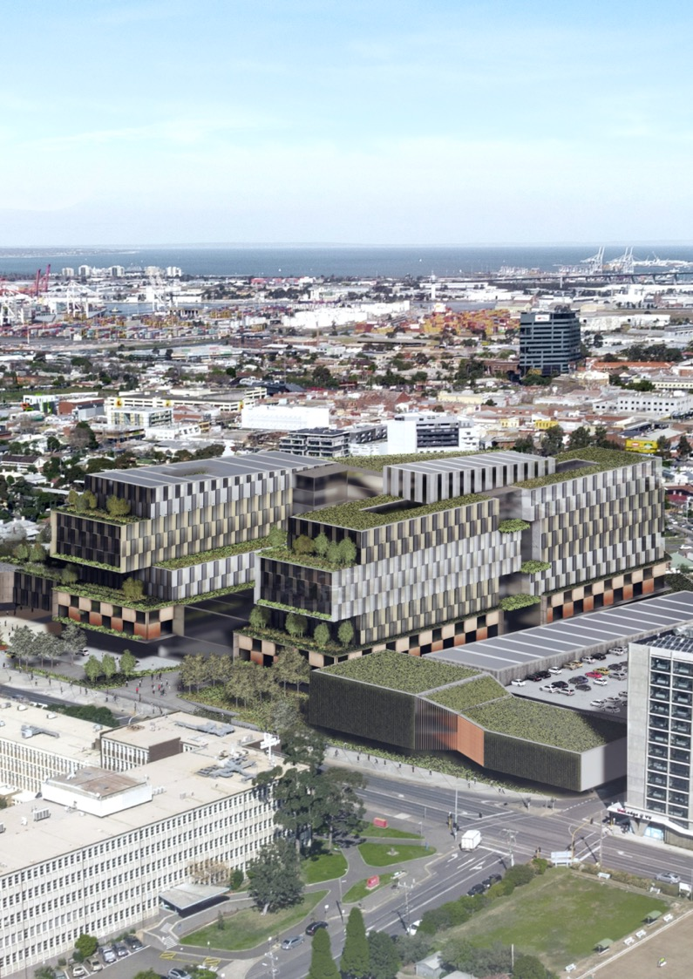

Consultation report: the next heople’s hospital

Page 15

50 Lonsdale Street

Melbourne 3000 VIC Australia

GPO Box 4057

Melbourne 3001 VIC Australia

**vhhsba.vic.gov.au**

Page 16

 facebook.com/**vhhsba** twitter.com/**vhhsba**

 linkedin.com/company/**vhhsba** vimeo.com/**vhhsba**

